**MC 6050 Accelerometer and Gyroscope with Bluetooth HC-05 and LCD Display**

**Image**

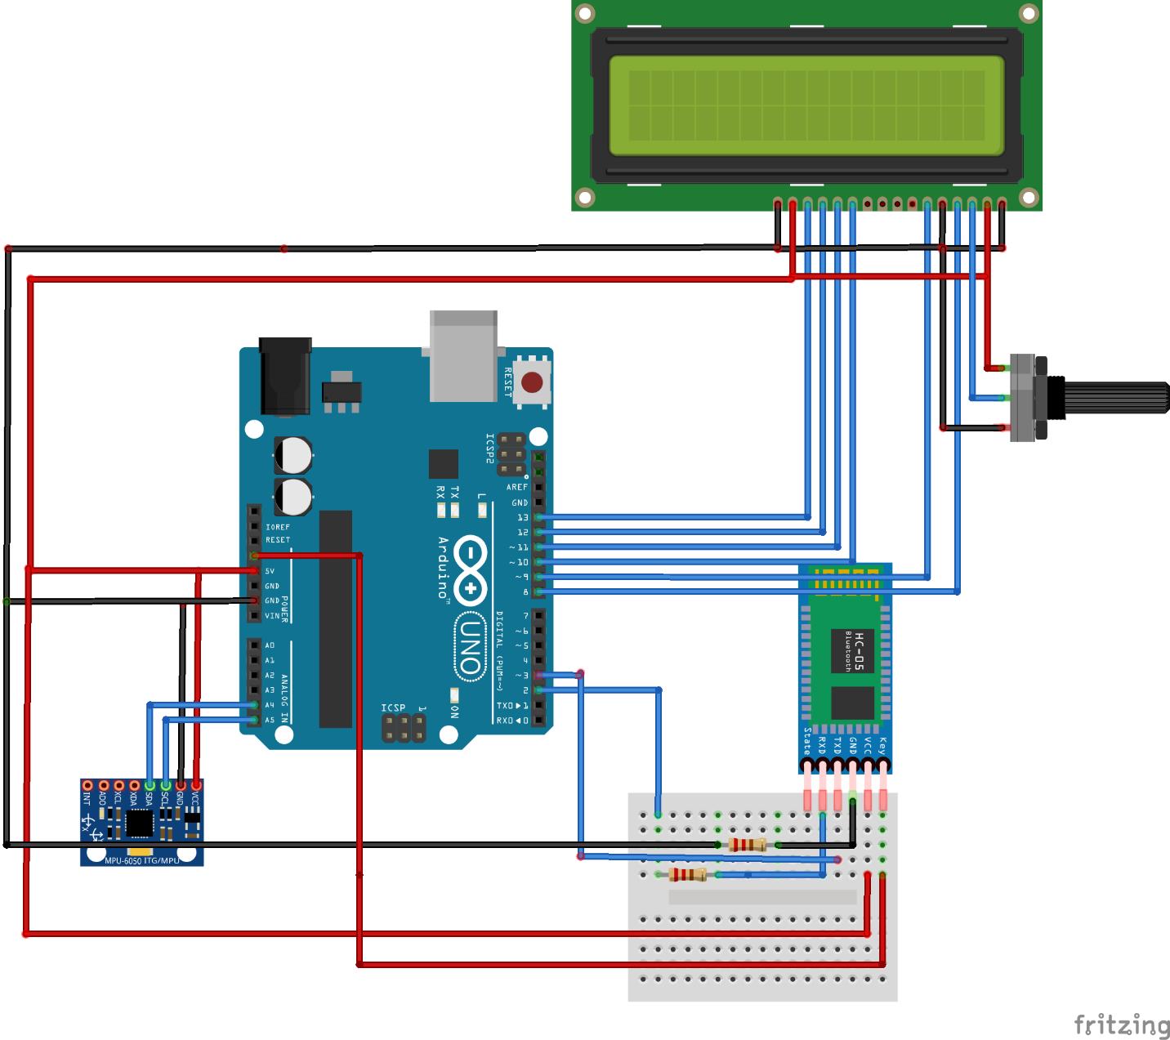

**Requirements:**

1. **1k OHM and 2.2k Ohm resistor**
2. **Arduino UNO or MEGA**
3. **Bluetooth Module HC-05**
4. **LCD 16x2**
5. **MC 6050**
6. **Jumper Wires**
7. **Potentiometer**

**WORKING**

**HC-05:**

It is advised to download datasheet of HC-05 and read all commands on it for AT configuration. A common issue faced by me was conversion of HC-05 to DATA mode from AT mode.

It took me 2 days to realize this issue. It is important to convert it from AT mode to DATA mode via AT+RESET command. If HC-05 is blinking with a delay of 1000ms it is in AT mode.

Connect the pins as shown above except now only for HC-05 mode.

* Burn code in Arduino and type in AT in serial monitor.
* If it says OK it is in AT mode and functional.
* If it does not say OK remove Arduino USB hold button on HC-05 keep holding it , now plug in USB and leave button.
* To convert from AT mode to DATA mode type in AT+RESET now it will blink faster or with lesser delay. It is now in DATA mode.
* Download app Serial Bluetooth Terminal and try pairing your phone with Bluetooth
* On Bluetooth of your phone, default password would be 0000 or 1234, you can also change it in AT mode with command AT+PASS=”8888”
* Once connected with Bluetooth means it will send and receive data
* We will use Softserial variable comm(tx,rx) //putting in pin numbers for transferring and receiving data.
* Command for writing onto Bluetooth is comm.write(“HELLO”) and reading will be if comm.available>0
* Code has been provided it is more easy to learn from it .

**MC-6050:**

This is GyroScope and Accelerometer it is advised to interface it in another small breadboard for moment purposes it is moved so entire breadboard and connections might get disturbed as well.

If your MC-6050 is not being detected provide 5v at VIO.

**LCD Interfacing**

LCD interfacing has to be just as shown in image. It is important to change declared pins as in image while building circuit. Do not forget to use LCD crystal library. It is advised to run LCD sample code before uploading the finalized circuit code.